**Jeff Brown**

Jeff Brown was born Richard Chester Brown in 1926. Originally a child actor, he became Jeff Brown because Actors Equity already had a Richard Brown as a member. A graduate of the Professional Children's School, he provided a child's voice in a radio drama and appeared onstage.

Jeff Brown had worked in Hollywood and as an editor and writer in New York before creating Flat Stanley.

The idea for Stanley came to him one night at bedtime when his sons, J. C. and Tony, were young. One asked what would happen if the big bulletin board on the wall were to fall on J. C., and Jeff answered that he would most likely wake up flat. This led to the Stanley stories being written!

Jeff died in 2003.

[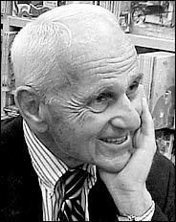](https://www.goodreads.com/photo/author/43329.Jeff_Brown)