**Emma Carroll**

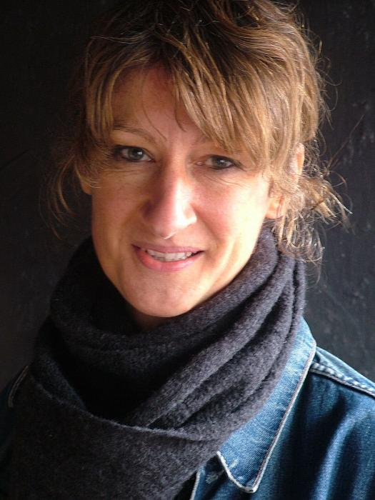

For many years Emma was an English teacher in a secondary school in Devon. Now, she writes full time. It’s her absolute dream-come-true job! After school, Emma worked as a reporter on a local newspaper. From there, she went to university to study English Literature. After backpacking around the Middle East, South America and Australia, she qualified as a teacher.

Many years later, she bought herself a lovely big notebook and some new pens. She enrolled on the MA Writing for Young People at Bath Spa University, and got writing again. Her book ‘Frost Hollow Hall’ was started on the MA course. It was her first novel, and took two years and many cups of tea to write. She has now written eight books with historical fiction themes. She lives in the Somerset hills with her husband and two Jack Russell terriers.

**Four More Things about Emma:**

• She is obsessed with snow.

• Her dogs Pip and Bertie snooze next to her when she’s writing.

• She has been a vegetarian since the age of 11.

• She love peanut butter AND marmite AND cucumber on toast!