**Barry Hutchison**

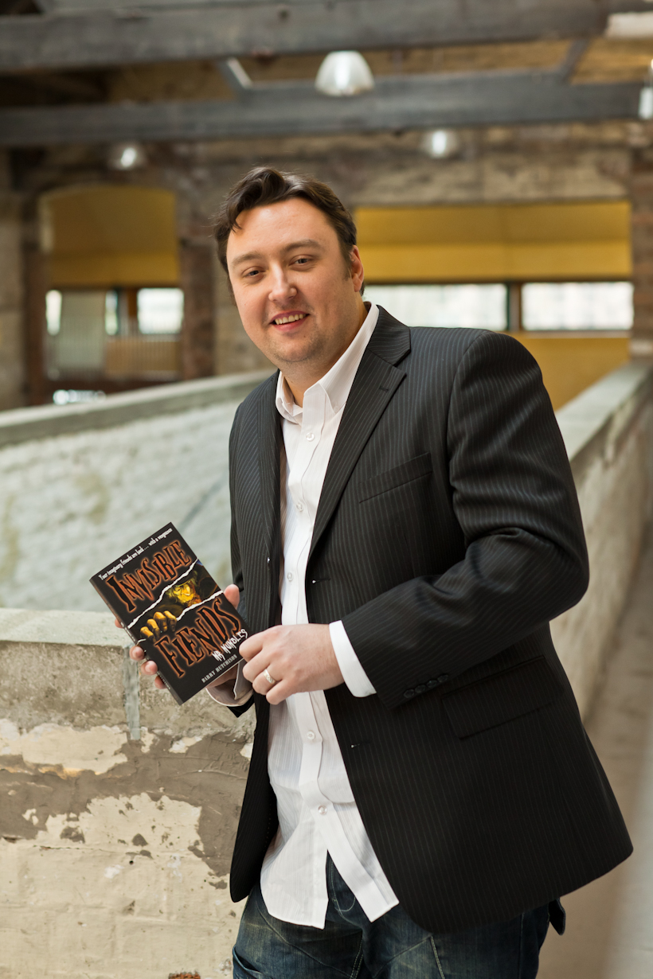

Barry is from the Highlands of Scotland and lives in Fort William. He decided to become a writer at the grand old age of 8.

As well as his Invisible Fiends series, Barry has written screenplays and has written for the Man of Action, Ben 10 books.

A recent venture is the CITV comedy series Bottom Knocker Street, which was aired in 2013. Barry was also involved in forming the Trapped by Monsters website ([www.trappedbymonsters.com](http://www.trappedbymonsters.com)), which aims to encourage reluctant readers to read a variety of genres.

Visit the website[www.](http://www.barryhutchison.com/)**[barryhutchison](http://www.barryhutchison.com/)**[.com/](http://www.barryhutchison.com/)