**Teresa Flavin**

[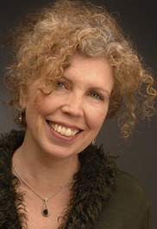](https://www.goodreads.com/photo/author/430332.Teresa_Flavin)

Teresa Flavin was born in New York and grew up in several New England states. The houses she lived in were always full of books and she loved to read, especially the Nancy Drew mysteries.

Teresa went to art school and studied illustration at Massachusetts College of Art and Design. She also completed a Master of Fine Arts degree, so that she could teach.

In 1995, she moved to Glasgow with her husband. She has a studio there, which is part of a renovated factory. From there, she has illustrated a variety of children’s books. She sometimes also exhibits her paintings. In 2006 she was awarded a Scottish Arts Council New Writer’s Bursary, which led to “The Blackhope Enigma” being published.