**Megan Rix**

[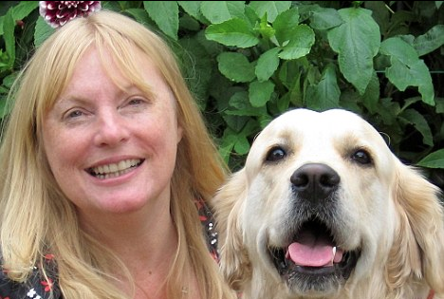](http://www.google.co.uk/url?sa=i&rct=j&q=&esrc=s&source=images&cd=&cad=rja&uact=8&ved=2ahUKEwiZ5JCj1NDcAhURfxoKHdHCAqsQjRx6BAgBEAU&url=http://www.meganrix.com/the-puppy-that-came-for-christmas-in-the-daily-mail/&psig=AOvVaw3tjOiiG625KllNarycI6J2&ust=1533377979289411)

Megan Rix was born in London in 1962. She is the oldest in a family of four children.

When she was 18, she set off on her own to travel around America and Canada and then became an exchange student at Kutztown, Pennsylvania. She taught children with learning difficulties back home for a few years.

Her first book was published in 1997, under her real name of Ruth Symes.

In 2006 she got married in Hawaii and the next year she and her husband, decided to help train Assistance Dogs.

Her first book written as Megan Rix was “The Great Escape” and was published in 2012.