**Julian Clary**

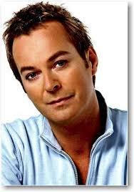

Julian Peter McDonald Clary (born 25 May 1959) is an English comedian and novelist.

Clary began appearing on television in the mid-1980s and became known for his deliberately stereotypical [camp](https://en.wikipedia.org/wiki/Camp_(style)) style.

Since then he has also acted in films, television and stage productions, and was the winner of [Celebrity Big Brother 10](https://en.wikipedia.org/wiki/Celebrity_Big_Brother_10) in 2012.