**Jill Tomlinson**

[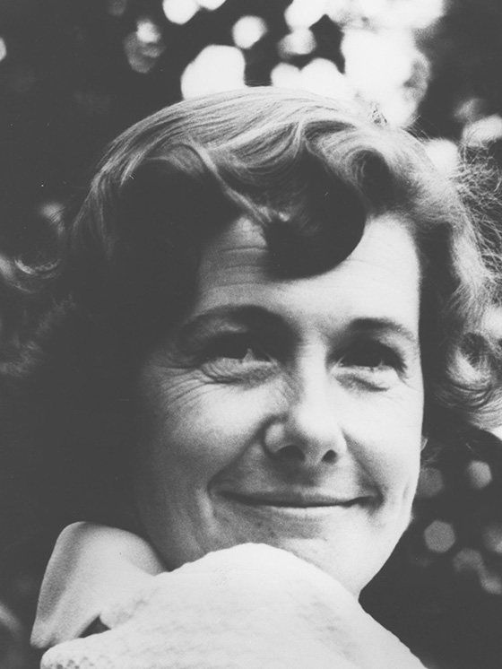](https://www.google.co.uk/url?sa=i&rct=j&q=&esrc=s&source=images&cd=&cad=rja&uact=8&ved=2ahUKEwimrYj2t9DcAhWG4YUKHYqUDWYQjRx6BAgBEAU&url=https://www.egmont.co.uk/books/author/106/jill-tomlinson&psig=AOvVaw0BFT5DIFAlJg8F0vIE2aVR&ust=1533370369562030)

Jill Tomlinson was born in1931 and never intended to be a writer.  She trained as an opera singer, and then decided to have a family whilst her voice matured.  Unfortunately she became ill and had to choose another career path to follow. She started on a journalism course, and by the third lesson decided she wanted to write for children.  Jill Tomlinson’s animal stories are much-loved and have been best-selling children’s books for nearly four decades. Jill died in 1976.