**Jill Murphy**

[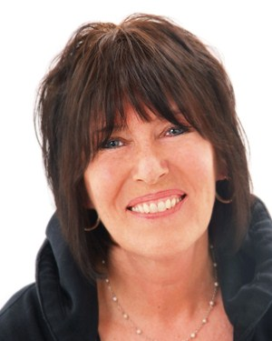](http://www.google.co.uk/url?sa=i&rct=j&q=&esrc=s&source=images&cd=&cad=rja&uact=8&ved=2ahUKEwjVlYjina3cAhXB16QKHZOlDZwQjRx6BAgBEAU&url=http://www.juniormagazine.co.uk/books/junior-meets-author-jill-murphy-as-the-seventh-worst-witch-book-is-published/16846.html&psig=AOvVaw0oWThO2R6-l5rdJejo-SfQ&ust=1532160755620507)

Jill Murphy was born in London on 5th July 1949. From the age of two, she was drawing pictures and when she was six, she started to make little books, which her mum still has.

Jill enjoyed school and then attended Chelsea Art School and Croydon Art School. Her first novel “The Worst Witch” was published when she was just twenty-four. It is based on her own experiences at a convent school. She then knew that she wanted to be an author/illustrator.

Jill is also well-known for her picture books about the Large Family.