**David Baddiel**

[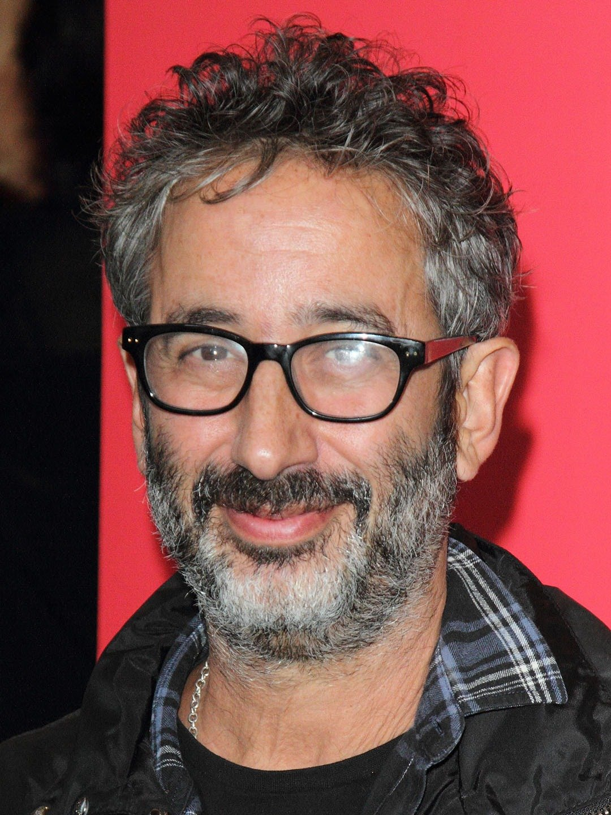](http://www.google.co.uk/url?sa=i&rct=j&q=&esrc=s&source=imgres&cd=&cad=rja&uact=8&ved=&url=http://google.com/search?tbm%3Disch%26q%3DDavid%20Baddiel&psig=AOvVaw20ndA8O202tq0_30Ph47U6&ust=1533375109763803)

David Baddiel was born on 28th May 1964 in Troy, New York and moved to England as a baby. He is best known for being a comedian and television presenter but now also as an author.

After school, David went to King’s College, Cambridge and graduated with a double first. After University, he started on his comedy career and then moved on to television.

David and his partner, Morwenna Banks, have a son and a daughter.