**Allan Burnett**

[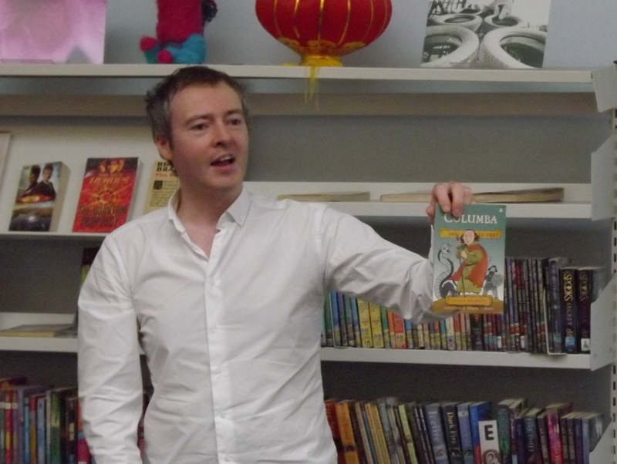](https://www.google.co.uk/url?sa=i&rct=j&q=&esrc=s&source=images&cd=&cad=rja&uact=8&ved=&url=https://blogs.glowscotland.org.uk/ea/Doonlibrary/2012/03/06/allan-burnett/&psig=AOvVaw2PlZTSV2qGyTf6UAIuQJrg&ust=1531917764112664)

Allan Burnett was born and brought up in the Western Isles. When he was 12, he spent several weeks travelling from South Uist to Sarajevo and back, visiting seventeen different countries. This led to his lifelong interest in history and culture.

After school, Allan studied at Edinburgh University, working at night telling ghost stories in the underground vaults of Edinburgh. He worked for a while as a journalist with the Herald Group newspapers.

He lives in Scotland and Sweden with his family.