**Adrian Edmondson**

[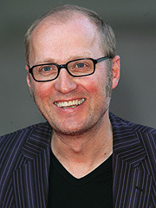](https://www.goodreads.com/photo/author/35037.Adrian_Edmondson)

Adrian Edmondson was born in Bradford on 24th January 1957. He is a comedian, writer, director, actor and musician. He is probably best known for his role in the television series “The Young Ones”, which he wrote with Rik Mayall.

Adrian attended Pocklington School in Yorkshire and then studied drama at Manchester University. He has been involved in comedy all his life since then on the stage and on screen.

In 1985, he married Jennifer Saunders and they have three daughters. Adrian has also been a finalist on “Hell’s Kitchen” and won “Celebrity Masterchef” in 2013.