**Theresa Breslin**

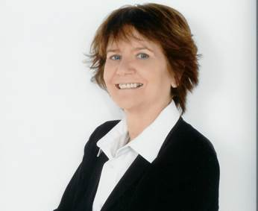

Theresa Breslin is an award winning author and has won the prestigious Carnegie Medal for “Whispers in the Graveyard”.

To date, Theresa has written over 30 books for children, some of which have been filmed for television and dramatised on radio.

Her novels cover many genres, including historical, fantasy, and science fiction.

Theresa was born in Scotland and once worked as a librarian.

She travels extensively to research her novels and promote children’s literature and literacy.