**Janis MacKay**

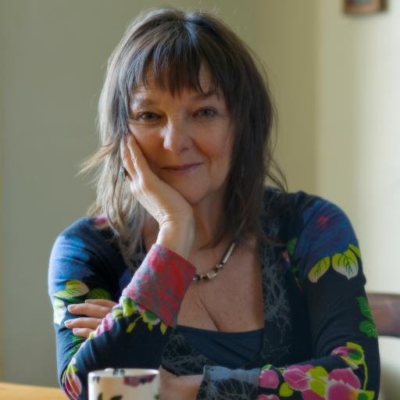

Janis MacKay is from Edinburgh but has travelled a lot. She has lived in France, Israel, Greece, London, Sussex and the far north of Scotland, but is now back in Edinburgh. She always wanted to be a writer but following advice to get ‘a proper job’, took off to London when she was just nineteen and trained to be a journalist. She worked on Fleet Street, but soon realised this wasn’t the kind of writing she wanted to do. So she went off round the world having all kinds of adventures – sailing yachts, sleeping on beaches and working on kibbutz to name a few. She then became a storyteller, drama teacher and voice teacher but always remembered her childhood dream – to be a writer. She then decided to go to Sussex University where she did an MA in creative writing.