**Hilary McKay**

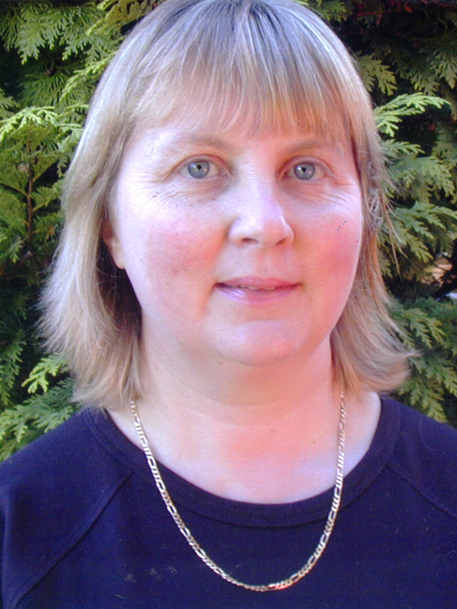

Hilary McKay was born in Boston, Lincolnshire and has three younger sisters. Although they were all keen readers, Hilary liked to escape to the local library for peace and quiet.

School days had good teachers and not-so good but Hilary continued on to St Andrews University, where she studied zoology and botany. She used to also sneak into the English lectures.

Hilary had various jobs but then started writing, which she still does today.

Hilary is married with two children.