**Laurence Anholt**

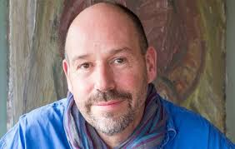

Laurence Anholt was born on 4th August 1959. He is the author/illustrator of more than 200 books, along with his wife, Catherine. His books have been translated into over 30 languages.

He attended Box Hill School, Falmouth School of Art and the Royal Academy of Art.

He has won several awards for his books over the years and he has also been to Downing Street and Buckingham Palace as a result of his books.

He has three grown up children and lives in Devon with his wife.