**Lari Don**

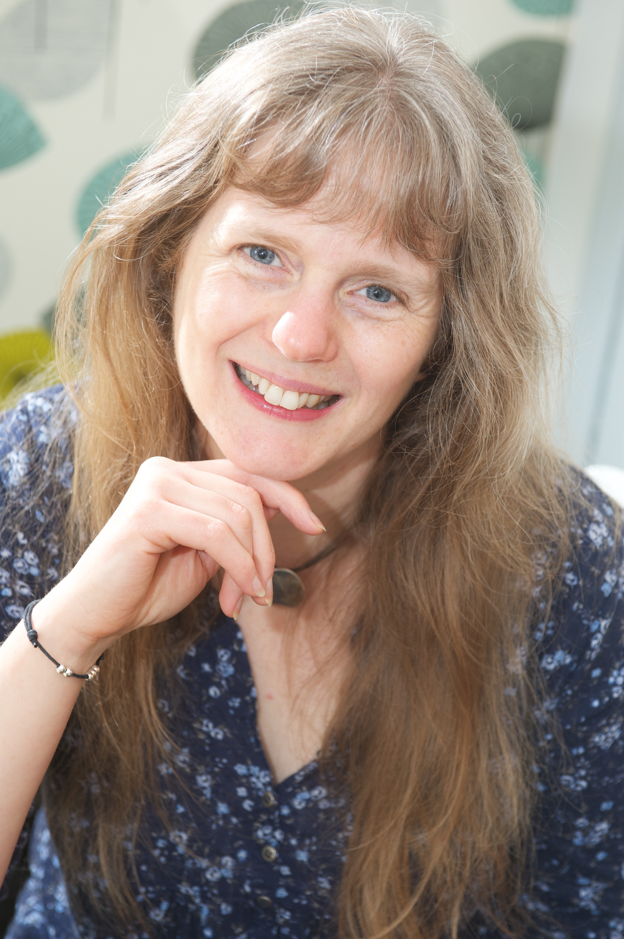

Lari Don was born in Chile and travelled widely in South and Central America before her family settled in North East Scotland, where she went to school.

Lari worked in politics, as a press officer, before becoming a full time author and storyteller. She now writes full-time and has written everything from picture books for younger readers to books for young adult readers and for those in between. She is well known for her “Spellchasers” trilogy and “The Fabled Beast Chronicles”.

As a storyteller, Lari also re-tells many of Scotland’s traditional tales.

You can find more out about Lari on her website at <http://www.laridon.co.uk/>. You’ll also find her blog there with all the latest information on Lari.