**Jacqueline Wilson**

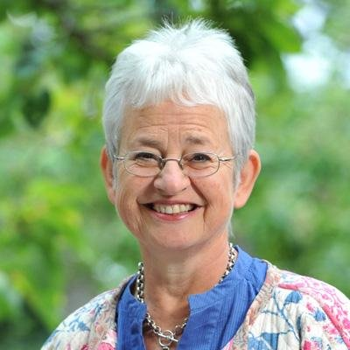

Jacqueline Wilson was born in Bath in 1945, but spent most of her childhood in Kingston-on-Thames. She always wanted to be a writer and wrote her first “novel” when she was nine, filling countless Woolworths’ exercise books as she grew up. Since having her daughter, Emma, she has been writing full time.

She has written over 70 best-selling books, and several have even been adapted for TV – most famously *The Story of Tracy Beaker*. Her signing sessions attract huge crowds of fans and last for hours! Over 25 million copies of her books have now been sold in the UK alone.