**Francesca Simon**

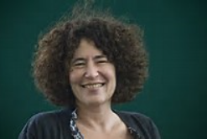

Francesca Simon was born on 23 February 1955 and spent her childhood on the beach in California. She went to Yale and Oxford Universities and now lives in North London with her family.

Although she started writing stories when she was 8, it was when she was reading lots of stories to her son that she felt inspired to write children’s books. One of her most successful characters is Horrid Henry. His stories have been published in 27 languages and have sold millions of copies worldwide. She is also very involved with encouraging young writers and has been a judge for several book awards. One of her proudest moments was receiving a Gold Blue Peter Badge in 2009.

Visit the website [www.horridhenry.co.uk](http://www.horridhenry.co.uk)

Francesca Simon was born in the United States. For ten years she worked as a freelance journalist. She now writes full-time and has had many books published including the best-selling Horrid Henry series. She lives in North London with her family.

Horrid Henry books and audio have sold over 15 million copies in the UK alone and CITV have made a hugely popular cartoon series based on the nation's favourite naughty boy. Francesca Simon is the third most borrowed children's author from UK libraries.