**Activities for…  
Dirty Bertie: Bogeys! By Alan MacDonald**

1. Draw a picture of Dirty Bertie meeting the Mayoress and write a short story about the visit for the local newspaper.
2. Find some of Dirty Bertie’s favourite words in the word square.

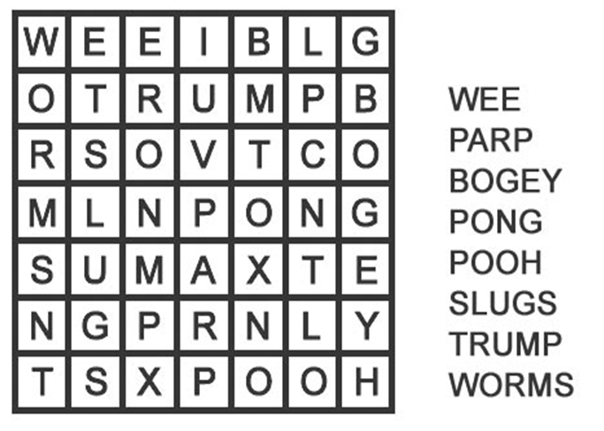

**Activities for…  
Dirty Bertie: Bogeys! By Alan MacDonald**

1. Colour in this picture of Dirty Bertie.

