**Alexander McCall Smith**

[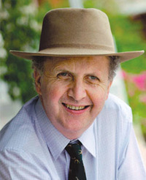](https://www.goodreads.com/photo/author/4738.Alexander_McCall_Smith)

Alexander McCall Smith is one of the world’s best-loved authors. He was a Professor of Medical Law for many years working in various universities in the UK and abroad before starting to write fiction. He has written many books for adults but is probably best known for “The No. 1 Ladies’ Detective Agency”. His books have been translated into 46 languages around the world. He visits Botswana at least once a year and also travels to many countries to meet his readers. He has received many awards for his writing along with twelve doctorates from universities around the globe.