**Cornelia Funke**

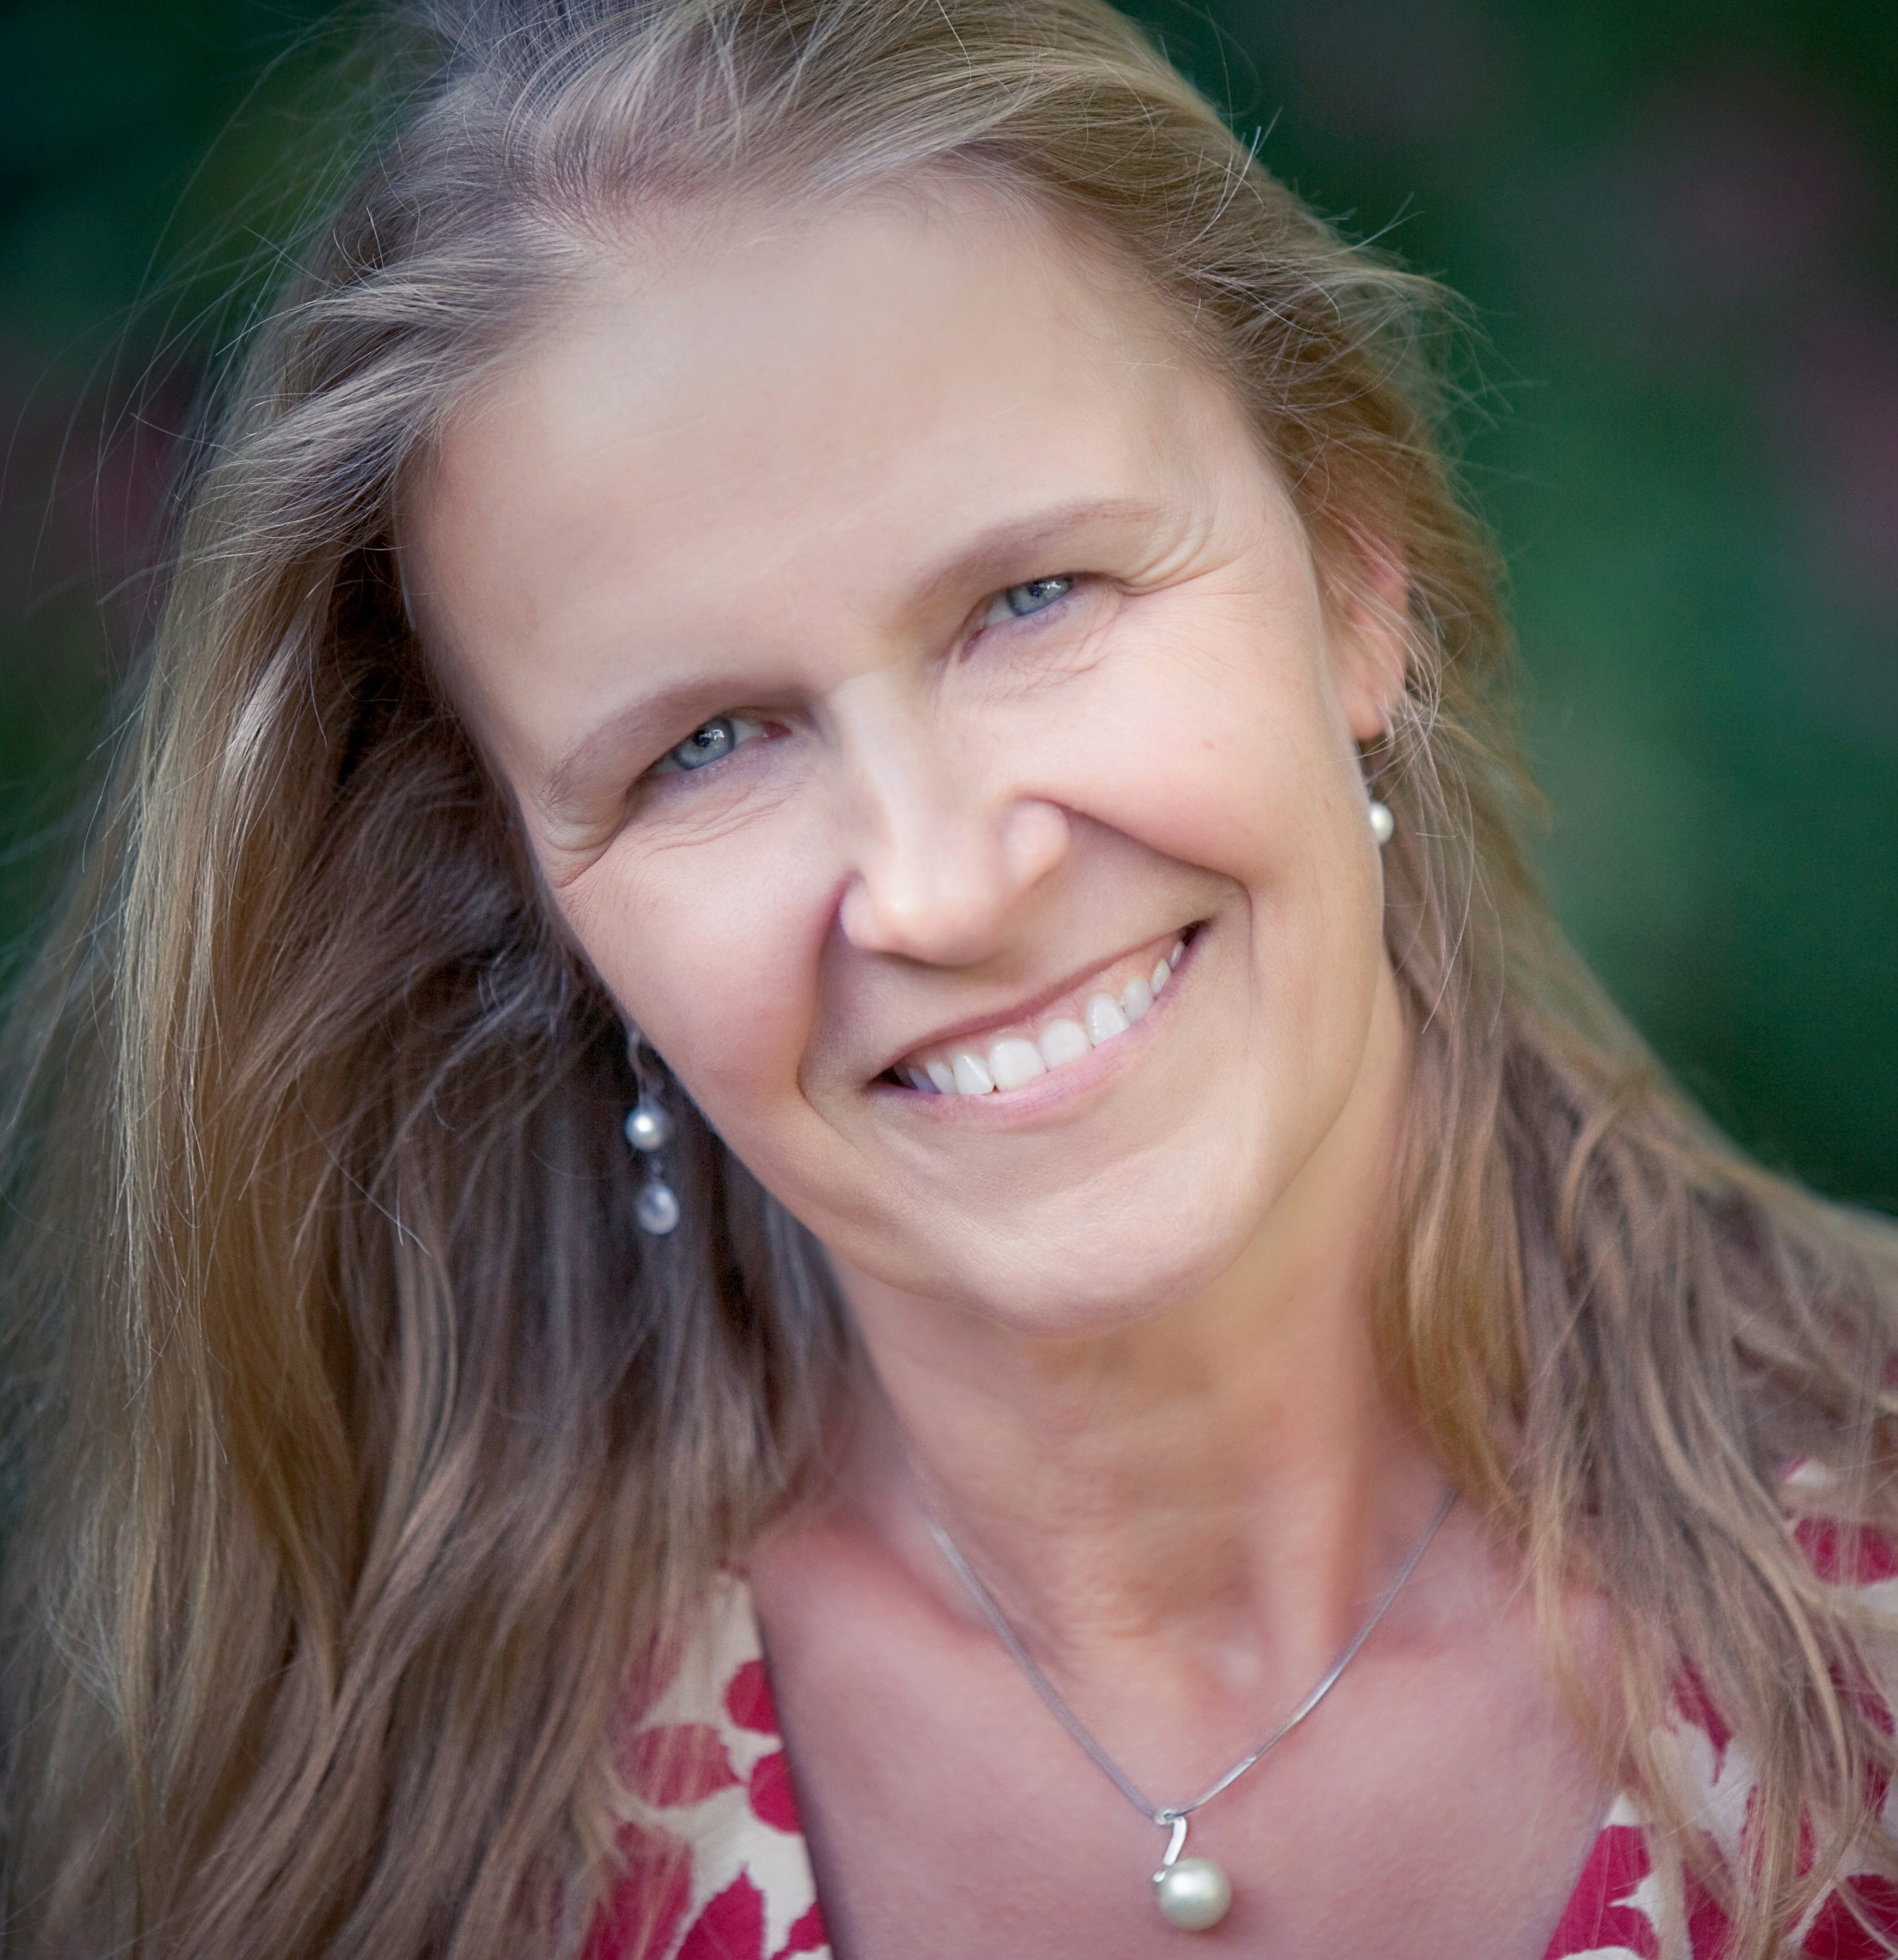

Cornelia Funke is a multiple award-winning German illustrator and storyteller, who writes fantasy for all ages of readers.

Amongst her best known books is the “Inkheart” trilogy. Many of Cornelia's titles are published all over the world and have been translated into more than 30 languages.

She has two children, two birds and a very old dog and lives in Los Angeles, California.