**Anne Fine**

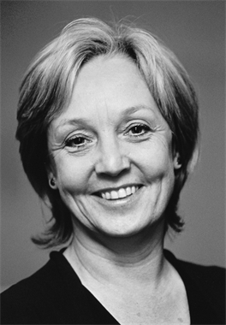

Anne was born in Leicester. When she was three, her mother had triplet girls, so Anne was sent off to school early. She says she can’t ever remember not being able to read. When she reached the top of infant school, she had to wait a whole year until the junior school would take her, so spent the year reading the piles of books in the head teacher’s office.

Anne married at twenty, which seems very young to her now. She had two daughters, and she and her philosopher husband, Kit, began a series of moves across Britain, America and Canada. In the end, Anne came back to Britain, where her children went to secondary school and university. Anne has a big hairy dog called Henry, lives in a stone house by a river, and enjoys walking and reading – especially walking on the flat along the river, and reading in the bath.