**Sam Angus**

[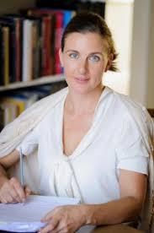](https://www.google.co.uk/url?sa=i&rct=j&q=&esrc=s&source=images&cd=&cad=rja&uact=8&ved=0ahUKEwjmgKvsu_DXAhXKZlAKHT5-AnIQjRwIBw&url=https://www.edubuzz.org/lennoxauthoraward/archive/sam-angus/&psig=AOvVaw2o-Gyf3NTARtZGSHEqjVjB&ust=1512480673523883)

Sam Angus was born in Italy and grew up in France and Spain. She studied English Literature at Trinity College, Cambridge, where she kept a dog until he was discovered being smuggled out in a laundry basket.

As well as teaching English, Sam also worked in the fashion industry for a number of years but now writes full time.

Sam likes to write in an empty house but when her children were young, she sometimes had to hide in the car to write.

Sam lives between Exmoor and London.