**H.L. Dennis**

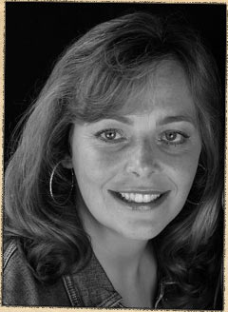

Helen was born on 23rd February 1970 in Brighton and still loves living by the sea. As a student, she worked in a book shop, which she loved. After training to be a teacher, she worked in a boarding school for deaf children. She, also at one point, was a storyteller from a Native American tepee set up in her garden. Although now an author, she still teaches part-time at Ocklynge School in East Sussex. Her daughter, Meggie, helped build the “Secret Breakers” series but her dog, Benji, proved to be no help at all.