**Cliff McNish**

Cliff was born in Sunderland on a hot summer night when the electricity in the house had failed. He moved around a lot as a child and dreaded always having to start a different school and make new friends. He was, according to his school reports, a day dreamer and wasn’t much of a reader apart from comics. A teacher gave him “The Magician’s Nephew” and suddenly he wanted to be C.S. Lewis.

He drifted from university and went to work in a warehouse, packing boxes. He was promoted to the IT department and then to Project Management, which lasted for 20 years.

His daughter loved the stories he made up for her and that is how “The Doomspell Trilogy” came to be. Cliff has now been writing for 17 years and is still enjoying it.

[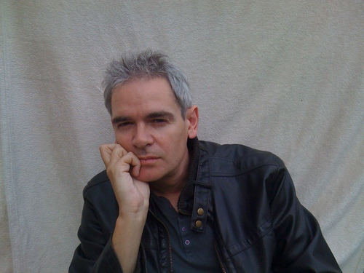](https://www.google.co.uk/url?sa=i&rct=j&q=&esrc=s&source=images&cd=&cad=rja&uact=8&ved=0ahUKEwiG1dDhq8vYAhUJIuwKHbKfAI4QjRwIBw&url=https://twitter.com/cliffmcnish&psig=AOvVaw1zO2f1lFvkJRGrRBretxvr&ust=1515602982527743)