**Ross MacKenzie**

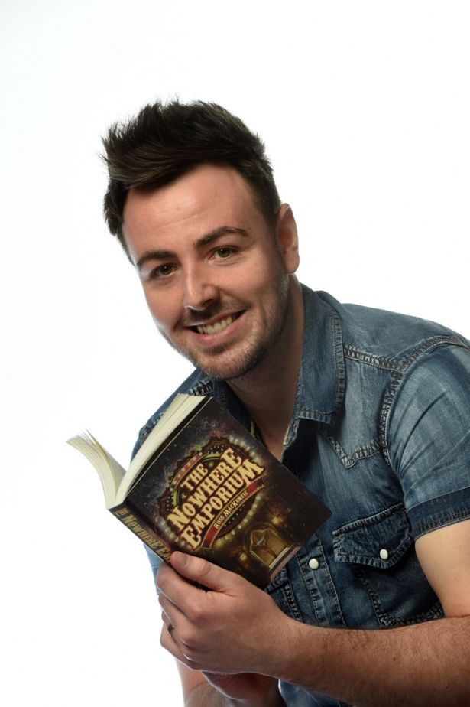

Ross MacKenzie is the author of Zac and the Dream Pirates and The Nowhere Emporium. He grew up in Renfrew and knew from a young age that he wanted to become a writer. In fact, he wrote his first book – an illustrated short story about a hungry crocodile called Crunchy Colin – in a smuggled school jotter when he was seven. Ross is a graphic designer by day. He still lives in Renfrew with his wife and baby daughter, but spends much of his spare time in another world.

On writing: “*Books are one of my great pleasures. I can remember vividly how I felt as a child, curled up in bed, eager to set off on the next great adventure. I became a writer for children because I love the magic of great stories – and my dream is that readers will one day feel the same way about my books.”*