**Rachel Renee Russell**

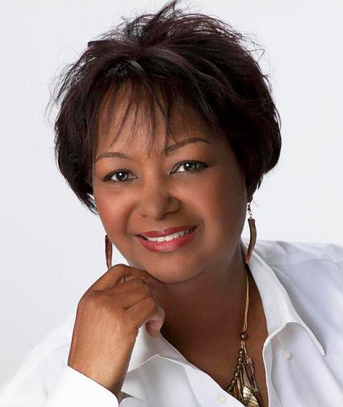

Rachel Renée Russell is the author of the #1 *New York Times* bestselling book series, *Dork Diaries*. She’s an attorney who prefers writing tween books to legal briefs. Mainly because books are a lot more fun and pyjamas and bunny slippers aren’t allowed in court.

Rachel first introduced us to Nikki Maxwell in 2009 and since that time she has written 11 books in the series which have sold more than 30 million copies worldwide. Some of the Dorky books that have been translated into over 36 different languages.

Visit the website [www.dorkdiaries.com](http://www.dorkdiaries.com)