**Pamela Butchart**

[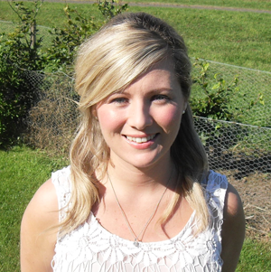](http://www.google.co.uk/url?sa=i&rct=j&q=&esrc=s&source=images&cd=&cad=rja&uact=8&ved=0ahUKEwjy4O-cx4rTAhUH1RoKHY05BOIQjRwIBw&url=http://www.lindsayliteraryagency.co.uk/pamela-butchart/&psig=AFQjCNEINkSVNfwJsI6zBcM2F-S0WFHNdA&ust=1491386815928801)

Pamela grew up in a house full of pets with parents who were bonkers. Pamela is now a high school teacher, teaching philosophy having gained an MA from Dundee University and a PGDE from Edinburgh University.

Pamela always loved and collected children’s books but never thought she could write until her fiancé bought her a “How to Write for Children” book one birthday. She now owes him for life! Much of Pamela’s inspiration comes from her own childhood and crazy bedtime storytelling with her gran.

Pamela won the Blue Peter best story book award in 2015 and the Children’s Book Award in 2016