**Kate O’Hearn**

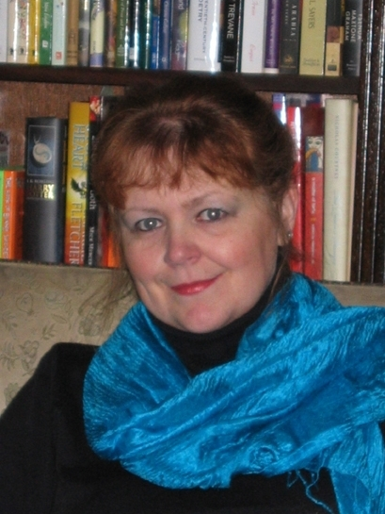

Kate O’Hearn was born in Toronto, Canada but has lived in many American cities as well as parts of Europe and England.

Her many adventures on her travels with her family and the stories her parents told on the long journeys they made, fuelled her desire to write.

Although she has had many jobs, some in the fashion and film industries, writing is what she really always wanted to do.