**Caroline Lawrence**

[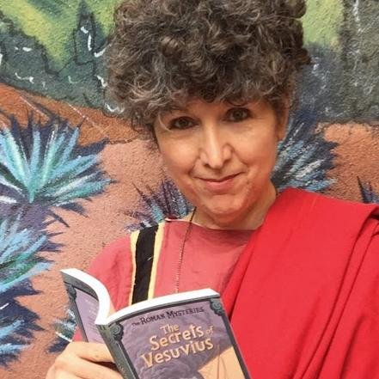](https://www.google.co.uk/url?sa=i&rct=j&q=&esrc=s&source=images&cd=&cad=rja&uact=8&ved=0ahUKEwiUtq2QqujWAhUD1xoKHXCNBy0QjRwIBw&url=https://twitter.com/carolinelawrenc&psig=AOvVaw3XzNHkiP1nJEcItcUqk9NV&ust=1507803018661692)

Caroline Lawrence was born in London in 1954 but grew up in California with her parents and younger siblings. She studied classics at Berkeley and then classical art at Newnham College, Cambridge. She went on to teach French and Latin in a London primary school before having her first book published in 2001.

Caroline is best known for her Roman Mystery series, which has won many awards and has been published in different languages.