**Veronica Cossanteli**

[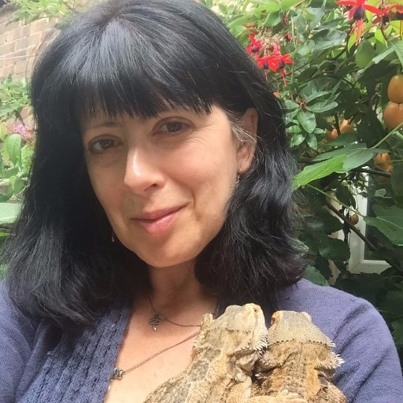](https://www.google.co.uk/url?sa=i&rct=j&q=&esrc=s&source=images&cd=&cad=rja&uact=8&ved=0ahUKEwjGuNa0iKXWAhXEmLQKHbkDDmcQjRwIBw&url=https://twitter.com/vcossanteli&psig=AFQjCNGDhZ75H79VoSeC7PW7fvZM8qrI8Q&ust=1505491868575736)

Veronica Cossanteli grew up in Hampshire and Hong Kong. As she had an imaginary pet dinosaur, she wanted to be a palaeontologist but found out that was more to do with science than imaginary creatures.

Veronica was sent to boarding school when she was 11 and was homesick, so took to writing stories. She received her first rejection slip at 13. She stuck with her ambition though, to become a writer.

She now lives in Southampton with three cats, two snakes, a guinea pig and a large number of lizards.