**Tim Collins**

[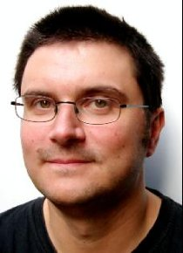](https://www.google.co.uk/url?sa=i&rct=j&q=&esrc=s&source=images&cd=&ved=0ahUKEwii_byMgJ3WAhVJalAKHTovCvgQjRwIBw&url=https://www.susankmann.com/2010/08/author-interview-tim-collins.html&psig=AFQjCNHhTunIMTX4EWJEOW8LpBCYkz-Now&ust=1505214760396108)

Tim Collins was born on 1st April 1960 in Manchester and now lives in London.

He is the author of over 30 fiction and non-fiction books, including Dorkius Maximus and The Wimpy Vampire. His books have been translated into over 30 languages and The Wimpy Vampire series has sold over 100,00 copies in the UK alone.