**Elen Caldecott**

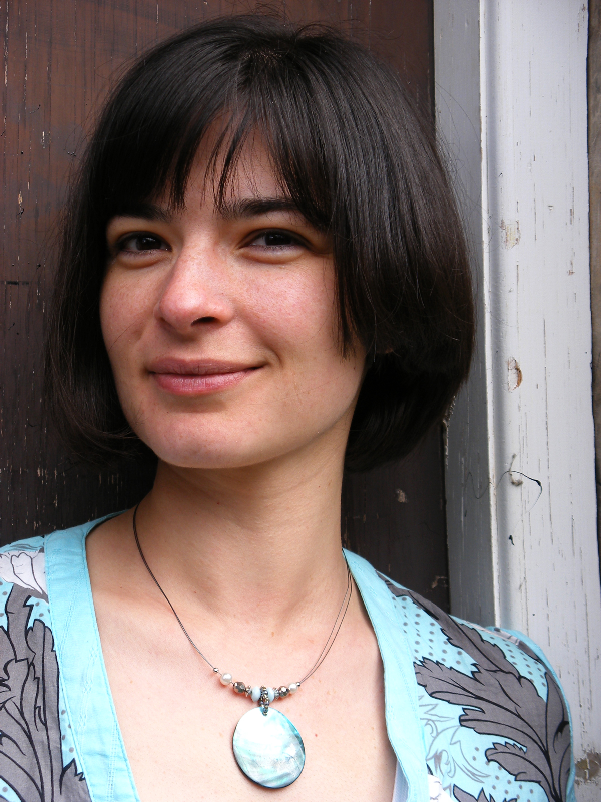

Elen Caldecott lives in Bristol with her husband and her dog, Biff. Before Biff arrived she had an imaginary dog called Augustus Snags. Before becoming a writer, she was an archaeologist, a nurse, a theatre usher and a museum security guard.

It was while working at the museum that she realised there was a way to steal anything if you think about it hard enough. Elen said, “I either had to become a master thief, or create some characters to do it for me, so I began writing.

The Great Ice Cream Heist came out of an encounter in my local park while I walked my dog”.

Visit the website [www.elansawsomeadventures.com](http://www.elansawsomeadventures.com)