**Dick King-Smith**

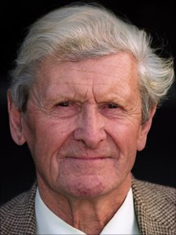

Dick King-Smith was born and raised in Gloucestershire, England, surrounded by pet animals. After twenty years as a farmer, he turned to teaching and then to writing children's books. Dick writes mostly about animals: farmyard fantasy, as he likes to call it, often about pigs, his special favourites. He enjoys writing for children, meeting the children who read his books, and knowing that they get enjoyment from what he does.   
  
Among his well-loved books is “[Babe, The Gallant Pig](http://www.randomhouse.com/catalog/display.pperl?isbn=0679873937)”, which was made into a major motion picture, and was nominated for an Academy Award.   
  
Dick currently lives with his wife in a small 17th-century cottage, about three miles from the house where he was born.