**Cressida Cowell**



Cressida Cowell lives in London with her husband Simon, daughters Maisie and Clementine and son Alexander.

She was born on 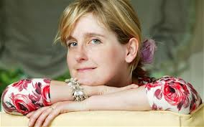15 April 1966 in London. As a child she enjoyed drawing and writing 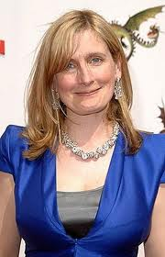stori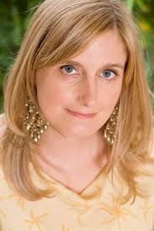es. She went to Oxford where she studied English and St Martin's and Brighton University, where she learned illustration.

“How to Train Your Dragon” has been made into a [film](http://uk.ask.com/wiki/How_to_Train_Your_Dragon_(film)?qsrc=3044), which was released on 26th March 2010.

Cressida has also won the Nestle Children's Book Award.