**Cassie Beasley**

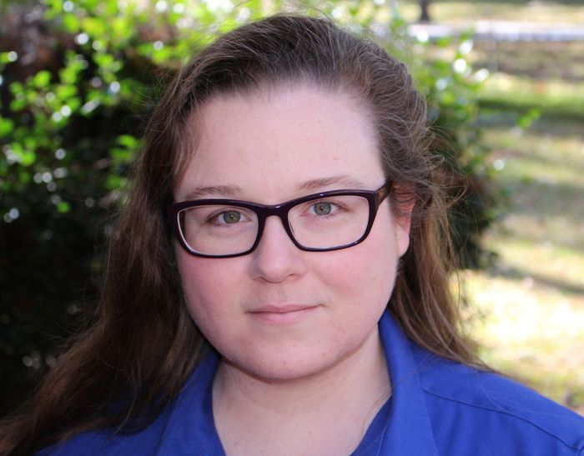

Cassie lives in rural Georgia with her best friend and younger sister, Kate Beasley who also writes children’s books.

Over the years Cassie has written a little bit of everything, including short stories and poems for adults, but she loves reading and writing fiction for young people most of all. Cassie attended the Vermont College of Fine Arts and was awarded a MFA in Writing for Children.