**Tom Palmer**

[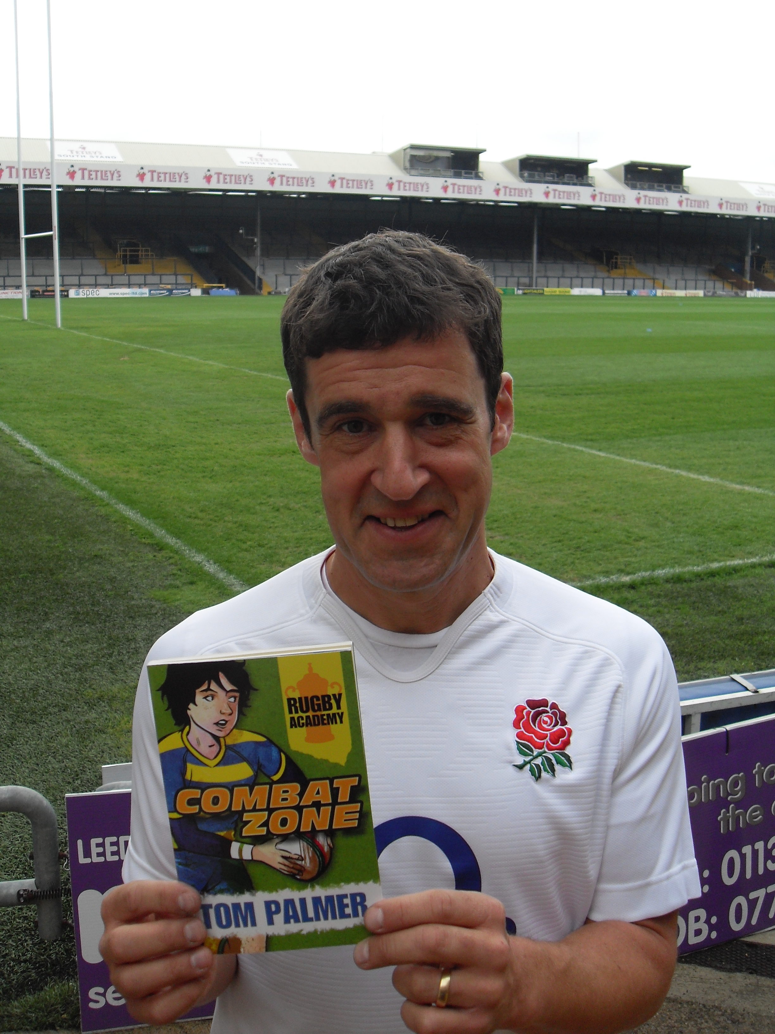](http://www.google.co.uk/url?sa=i&rct=j&q=&esrc=s&source=images&cd=&ved=0ahUKEwigsca4-JfUAhVQU1AKHUOzDWgQjRwIBw&url=http://tompalmer.co.uk/combat-zone/&psig=AFQjCNE_jGyLAn1iSKWTWTWsrhTtxJzn3A&ust=1496244809584852)

Tom Palmer was born in Leeds. Tom wasn’t a keen reader as a child. His mum was worried about this and encouraged him to read about football in newspapers and magazines as well as books. He eventually came to love books. From then on his life changed. He did his A-levels at night school and went on to do a degree in European Literature when he was 24.

After graduating, he worked in a bookshop, then a library and managed book festivals. Now he writes full-time.

He is married and has a daughter.

Visit the website <http://tompalmer.co.uk>