**Kjartan Poskitt**

[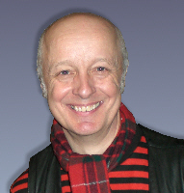](http://www.kjartan.co.uk/gigs/kjphotos/Kj%2009%20grey.jpg)

Kjartan Poskitt is an author and TV presenter who is best known for his series of books “Murderous Maths”.

He was born in Yorkshire on 15th May 1956. He writes in a room at the top of his house, where he is surrounded by old computers, guitars, magic tricks and his collection of 1500 Beano comics.

Author and illustrator Philip Reeve, who drew the illustrations for the “Murderous Maths” books, encouraged Kjartan into writing novels.