**Judith Kerr**

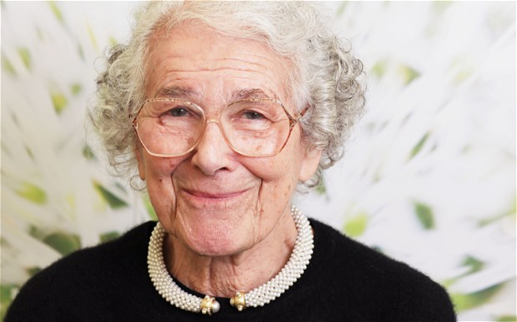

Judith Kerr was born in Berlin, the daughter of a distinguished German writer. She left Nazi Germany with her family in 1933 and fled across Europe, eventually settling in England. Years later she wrote about her experiences in her best-selling novel for children “When Hitler Stole Pink Rabbit”. She is also the author and illustrator of numerous picture books, including “The Tiger Who Came to Tea”, which was first published in 1968 and has since sold more than one million copies worldwide. She lives in England.