**Robin Stevens**

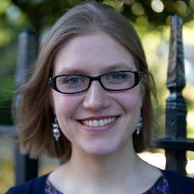

Robin Stevens was born in California but moved to England when she was 3 years old. She grew up in Oxford and has been making up stories all her life.

She spent her teenage years at Cheltenham Ladies College, reading lots of murder mysteries and hoping she would get to do some detecting herself. At university, she studied crime fiction and then worked in publishing as an editor. She is now a full time author and lives in London with her pet bearded dragon named Watson.

https://robin-stevens.co.uk