**Kimberly Newton Fusco**

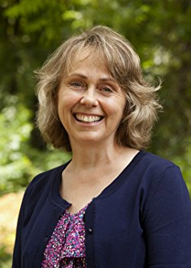

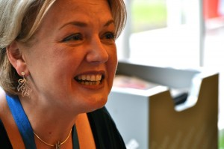

Kimberly Newton Fusco is the author of two previous, award-winning novels for children published in the USA, *Tending to Grace* and *The Wonder of Charlie Anne*.

Before becoming a novelist, Ms. Fusco, a graduate of the Columbia University Graduate School of Journalism in New York City, was an award-winning reporter and editor for the Worcester, Massachusetts, *Telegram & Gazette*.

She lives in Foster, Rhode Island, with her family.

Visit the website: www.kimberlynewtonfusco.com