**Helen Cresswell**

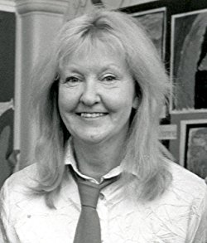

Helen started writing at the age of six. At that time, her primary interest was poetry. As well as being the author of many critically acclaimed novels, she wrote many television scripts, including Moondial, Lizzie Dripping, The Demon Headmaster and The Phoenix and the Carpet. In 2000, she received a BAFTA Writer’s Award and four of her books, including The Piemakers and The Bongleweed, have been runners up for the Carnegie Medal.

She passed away on 26th Sept 2005 at the age of 71 and her books are still read and enjoyed by children today.