**Gillian Philip**

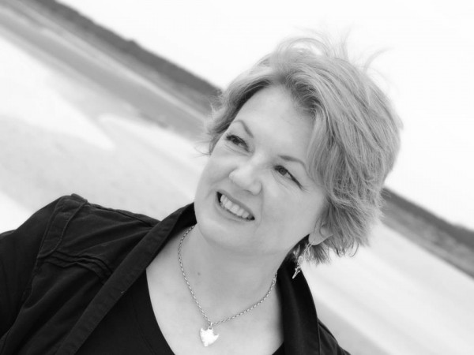

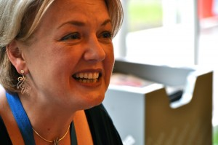

Gillian Philip lives in the North-East Highlands of Scotland with her husband, her children and lots and lots of pets, although she has made a promise not to get anymore pets.

Gillian has said that writing for a living is;

A) What she has always wanted to do

B) Occasionally frustrating

C) A lot of fun

As well as writing her own novels, Gillian is also a ghostwriter for several companies. Gillian was shortlisted for the Scottish Book Awards for “Mysteries of Ravenstorm Island: The Lost Children” and has been nominated for several other awards for her writing, including the prestigious Carnegie Medal.

Visit the website: www.gillianphilip.com/