**Ursula Le Guin**

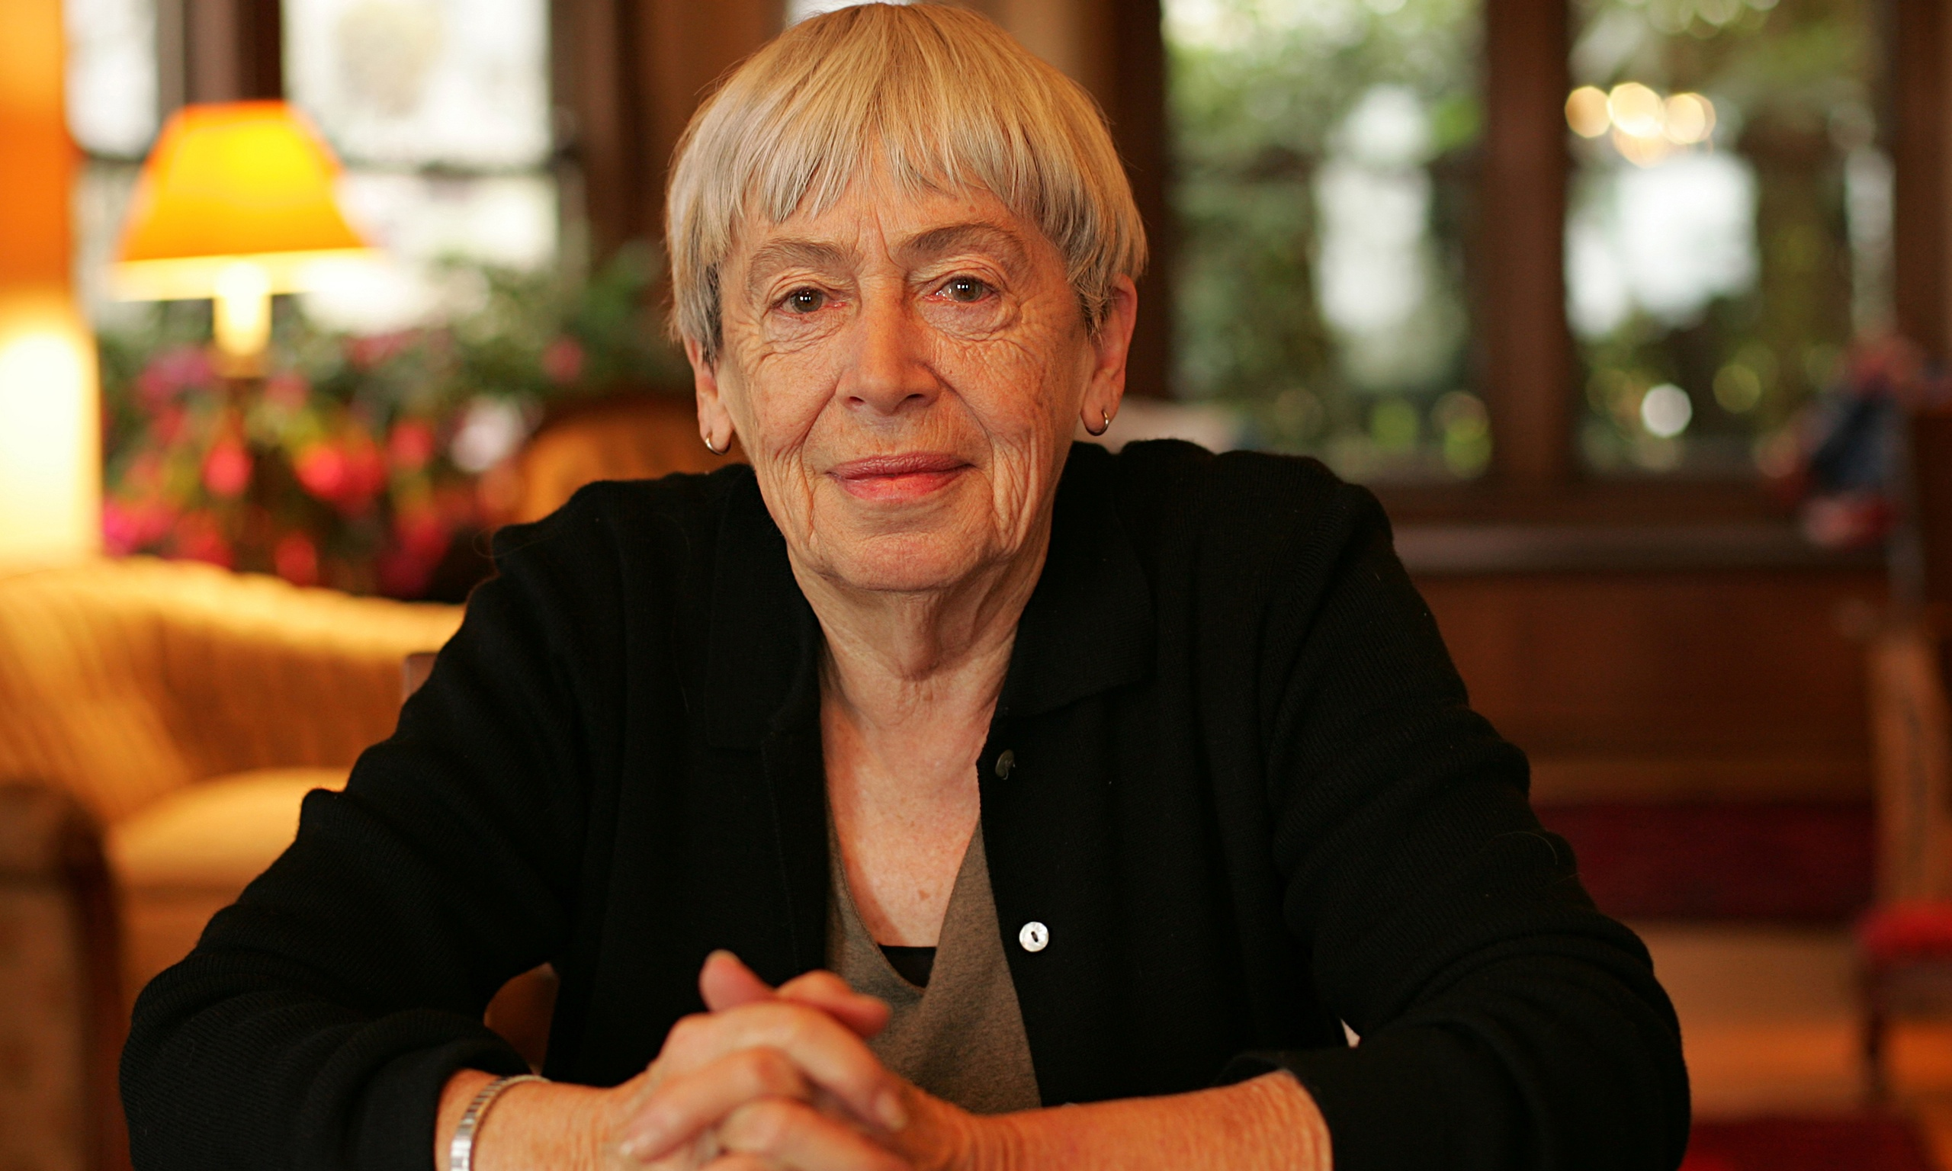

Ursula K. Le Guin was born in Berkeley, California on October 21st 1929. She is the author of more than one hundred short stories, two collections of essays, four volumes of poetry, and nineteen novels. Her writing, mainly science fiction and fantasy, has received many awards including the Hugo Award and Nebula Award.

Her best-known fantasy works, the Earthsea books, have sold millions of copies in America and England, and have been translated into sixteen languages. Ursula has lived in Portland, Oregon since 1959.