**Joan Lingard**

[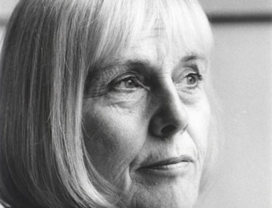](https://www.google.co.uk/url?sa=i&rct=j&q=&esrc=s&source=images&cd=&cad=rja&uact=8&ved=0ahUKEwjD4IXehJDTAhWD1RoKHWD9D1IQjRwIBw&url=https://www.edbookfest.co.uk/writers/joan-lingard&psig=AFQjCNEe8HSOCQ7J2hsqfxURkNyfFuah7g&ust=1491575101943277)

I was born in Edinburgh, in the very heart of its old town, the Royal Mile, but when I was two years' old I went to live in Belfast and stayed there until I was 18. It was there that I grew up, went to school, made my first friends, learned to read and write. Inevitably, then, Belfast and Northern Ireland have had a strong influence on my writing.

I started to write when I was eleven years old. I was an avid reader and could never get enough to read. My local children's library was small, the size of a shed or a garage, and I was soon able to read through what they had on offer. I always asked for books for birthdays and Christmas. One day, having just finished a book, I closed it and said to my mother straightaway, 'I've got nothing to read!' She got rather fed up hearing that so she turned to me and said, "Why don't you go and write a book of your own?" This proved to be a turning point in my life. I thought, "Why not? Why shouldn't I write a book?"