**Emma Shevah**

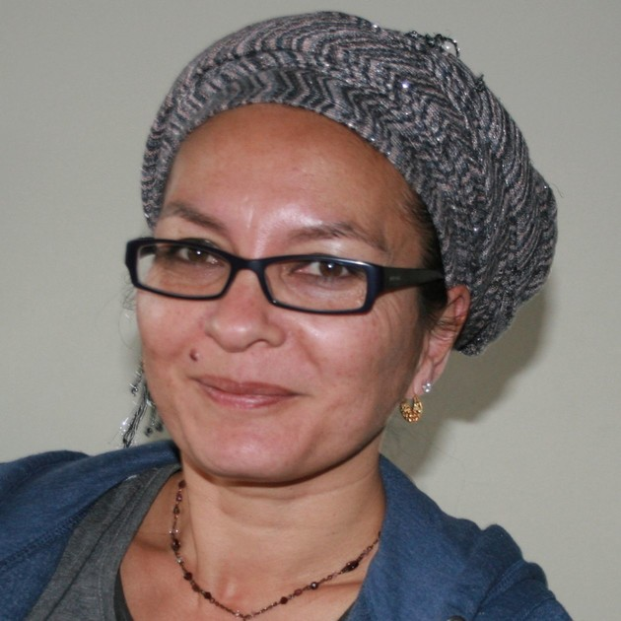

My name is Emma Shevah. My father was from Thailand and my mother was from Ireland (which probably makes me Thairish). I live in London but I’ve travelled far and wide and I love this planet so much I could go on about it for hours. I’m not finished with my travels yet, either: I have friends all over the world and hope to visit them all at some stage soon. I can speak a couple of languages and I’m trying to learn Thai but I’m a bad student with a head like a sieve. I cook yummy food but half the time I can’t be bothered to because I’d rather be writing. I love rain and I love storms. I read lots and I know a subordinate clause and a past participle when I see one because I teach English. I run around and clear up after four children, a dog called Spark and a baby tortoise called Slow Mo (short for Slow Motion, even though he’s speedy once he’s in the garden). And I’m busy writing more books. So I’d better get on with it!