**Cathy Cassidy**

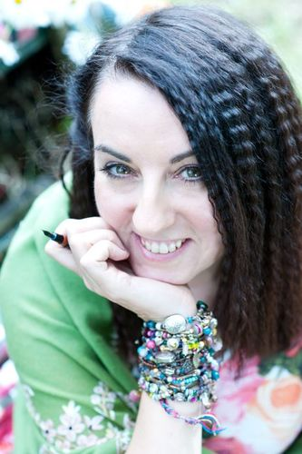

Cathy Cassidy was born in 1962 in Coventry. Cathy wrote her first picture book for her little brother when she was eight or nine.

Cathy went to Art College in Liverpool, and then got a job as fiction editor on the Jackie magazine. For 12 years she was the agony aunt for teen mag Shout, as well as teaching art in local primary schools.

Later, Cathy married her boyfriend Liam, went back to college and trained to be an art teacher. She taught in a Coventry secondary school for a few years and then moved to Scotland with Liam to start a family.

Visit the website: [www.cathycassidy.com](http://www.cathycassidy.com)