**Anne Cassidy**

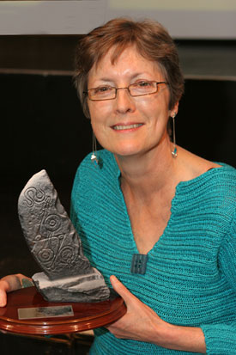

Anne Cassidy was born in 1952 in London and now lives in Essex. She worked for a number of years as a teacher before becoming an author. Her books have won or been shortlisted for many awards. “Looking for JJ” won the 2004 Booktrust Teenage Book Award.

Anne was one of the first people in the country to have plastic surgery on the NHS. She had her ears pinned back. When she came out of the operating theatre her whole head was bandaged up and her mother thought it looked like she had had brain surgery.

Her son doesn’t read any of his mum’s books but her husband reads them all and says he enjoys them!