**Andrew Lane**

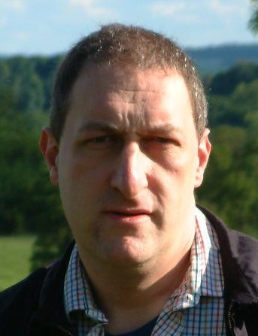

Andrew Lane was born in 1963 and also writes under the name of Andy Lane. He is a British author and journalist and describes himself as a lifelong Sherlock Holmes fan.

He has written spin-off books for many well-known TV shows including Doctor Who and Torchwood. Andrew lives in Dorset with his wife and son.

To find out more about Andrew Lane and his books go to [**http://www.youngsherlock.com/**](http://www.youngsherlock.com/)