[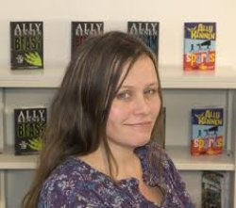](https://www.amazon.co.uk/Ally-Kennen/e/B0034NNDL8)

**Ally Kennen**

Ally Kennen grew up on a small organic farm near Exmoor with no flushing toilet, dead tadpoles coming out of the taps and rat infestations.

She did various jobs before becoming an author including working as an archaeologist, as a museum guard, as a giant teddy bear and as a singer/songwriter.

Her first novel “Beast” won the 2007 Manchester Book Award and many of her other novels have been shortlisted and won various awards.

She now lives in Somerset with her husband and four children.

An interesting fact about Ally is that no woman has ever beaten her at arm wrestling-yet!